**SILVER OAK UNIVERSITY**

**College Of Computer Application**

**Enrollment No : 2204030102703**

**Name :Kirtan Thakar**

**DAY -1 TASK**

**1.) h1 to h6 tag**

**<!DOCTYPE html>**

**<html>**

**<head>**

**<Title> H1 TO H6 TAGS </Title>**

**</head>**

**<body>**

**<center>**

**<h1>This is Heading 1</h1>**

**<h2>This is Heading 2</h2>**

**<h3>This is Heading 3</h3>**

**<h4>This is Heading 4</h4>**

**<h5>This is Heading 5</h5>**

**</h6>This is Heading 6</h6>**

**</body>**

**</html>**

**Info :**

**HTML Headings**

**HTML headings are defined with the <h1> to <h6> tags.**

**<h1> defines the most important heading. <h6> defines the least important heading.**

**Headings Are Important**

**Search engines use the headings to index the structure and content of your web pages.**

**Users often skim a page by its headings. It is important to use headings to show the document structure.**

**<h1> headings should be used for main headings, followed by <h2> headings, then the less important <h3>, and so on.**

**Output :**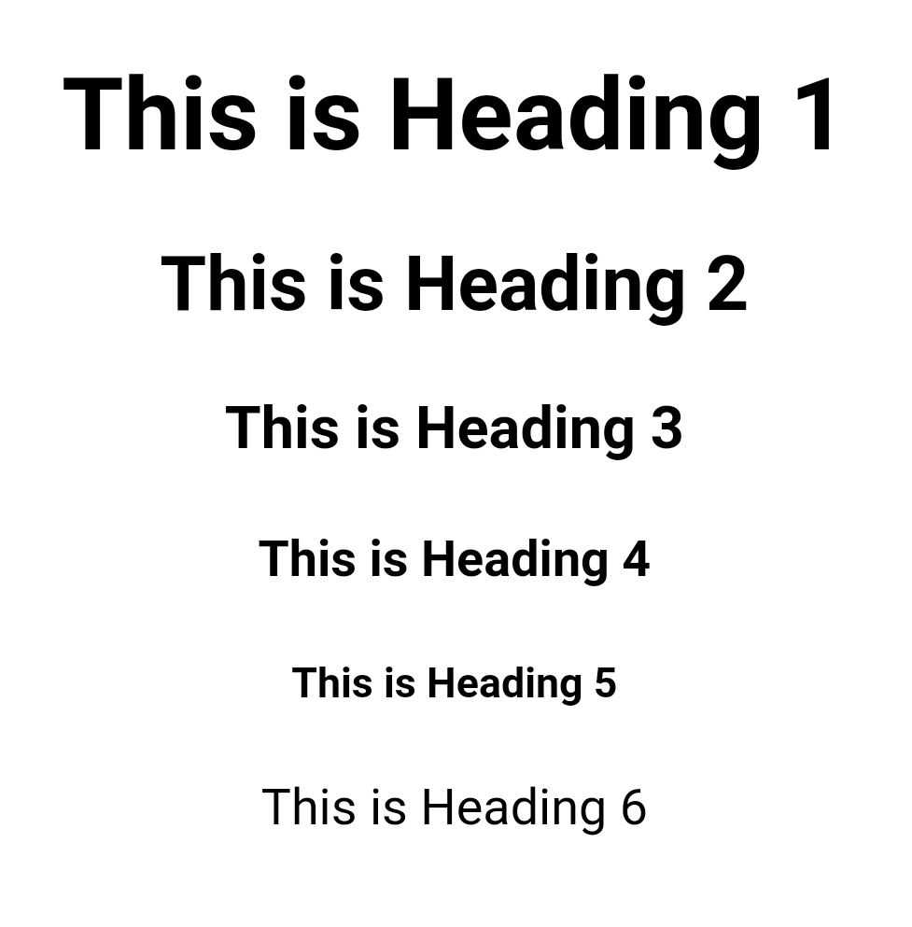

**2.) <!—font required Italic tag’s like**

**1.)Italics**

**<!DOCTYPE html>**

**<html>**

**<head>**

**<Title> Italic Text </Title>**

**</head>**

**<body>**

**<br>**

**<br>**

**<br>**

**<pre> <i>This is ITALIC TEXT Created by using tags <h3> < I > < / I > </h3></pre></i>**

**</body>**

**</html>**

**Info :**

## **Definition and Usage**

The **<i>** tag defines a part of text in an alternate voice or mood. The content inside is typically displayed in italic.

The **<i>** tag is often used to indicate a technical term, a phrase from another language, a thought, a ship name, etc.

Use the **<i>** element only when there is not a more appropriate semantic element, such as:

**Output :** 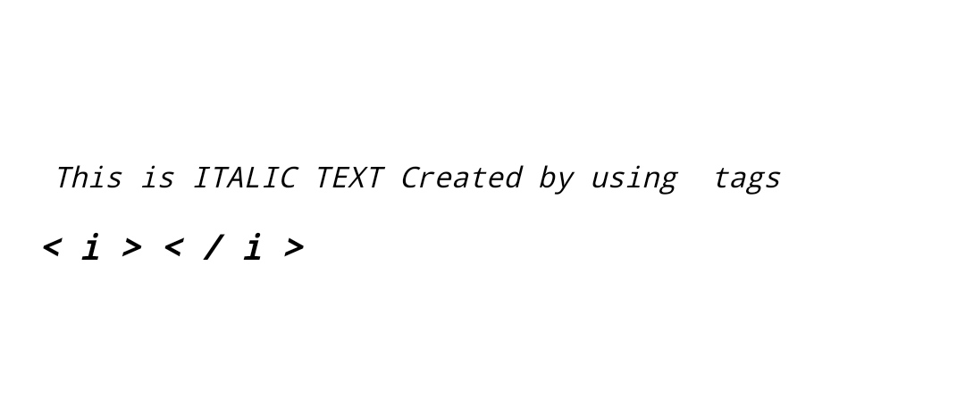

**2.) Emphasis**

**<!DOCTYPE html>**

**<html>**

**<head>**

**<Title> Emphasised Text </Title>**

**</head>**

**<body>**

**<br>**

**<br>**

**<br>**

**<pre> <em>This is EMPHASIS TEXT Created by using tags <h3> < em > < / em > </h3></pre></em>**

**</body>**

**</html>**

**Info :**

**Definition and Usage**

**The <em> tag is used to define emphasized text. The content inside is typically displayed in italic.**

**A screen reader will pronounce the words in <em> with an emphasis, using verbal stress.**

**Output :**

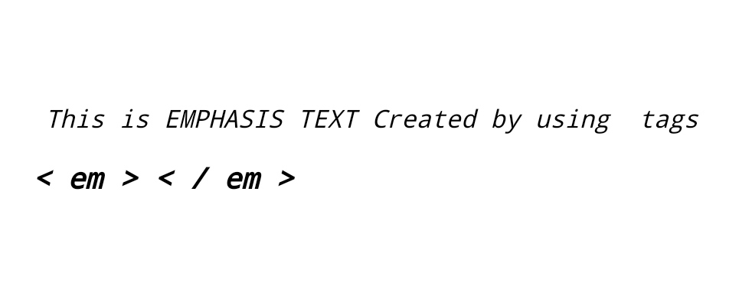

**3.)Citetion**

**<!DOCTYPE html>**

**<html>**

**<head>**

**<Title> Citetion Text </Title>**

**</head>**

**<body>**

**<br>**

**<br>**

**<br>**

**<pre> This is <cite> CITE </cite>TEXT Created by using tags <h3> < cite > < / cite > </h3></pre>**

**</body>**

**</html>**

**Info :**

## **Definition and Usage**

The **<cite>** tag defines the title of a creative work (e.g. a book, a poem, a song, a movie, a painting, a sculpture, etc.).

**Note:** A person's name is not the title of a work.

The text in the **<cite>** element usually renders in *italic*.

**Output :**

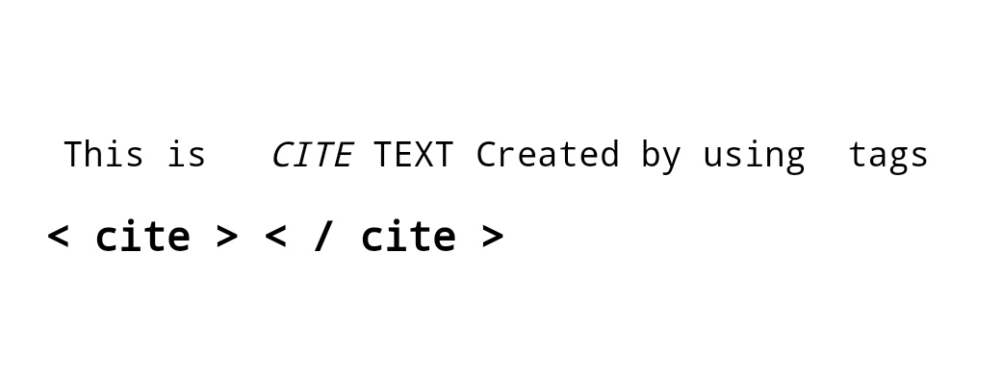

**4.)Defination**

**<!DOCTYPE html>**

**<html>**

**<head>**

**<Title> Defination Text </Title>**

**</head>**

**<body>**

**<br>**

**<br>**

**<br>**

**<pre> This is <dfn> DEFINE </dfn> TEXT Created by using tags <h3> < dfn > < /dfn > </h3></pre>**

**</body>**

**</html>**

**Info :**

## **Definition and Usage**

The **<dfn>** tag stands for the "definition element", and it specifies a term that is going to be defined within the content.

The nearest parent of the**<dfn>** tag must also contain the definition/explanation for the term.

**Output :**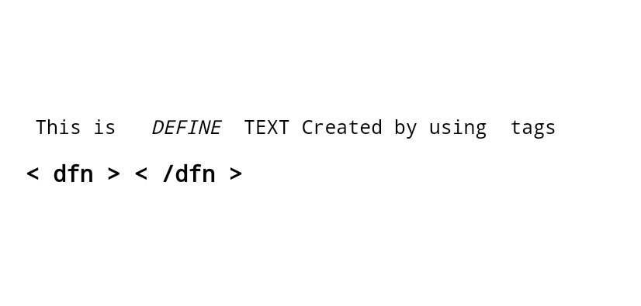

**3.)<!-- font required underline tag's like**

**1) underline**

**<!DOCTYPE html>**

**<html>**

**<head>**

**<Title> Underline </Title>**

**</head>**

**<body>**

**<center>**

**<pre> This is <u> UNDERLINED </u> TEXT Created by using tags <h3> < U > < / U > </h3></pre>**

**</center>**

**</body>**

**</html>**

**Info :**

**Definition and Usage**

**The <u> tag represents some text that is unarticulated and styled differently from normal text, such as misspelled words or proper names in Chinese text. The content inside is typically displayed with an underline. You can change this with CSS (see example below).**

**Output :**

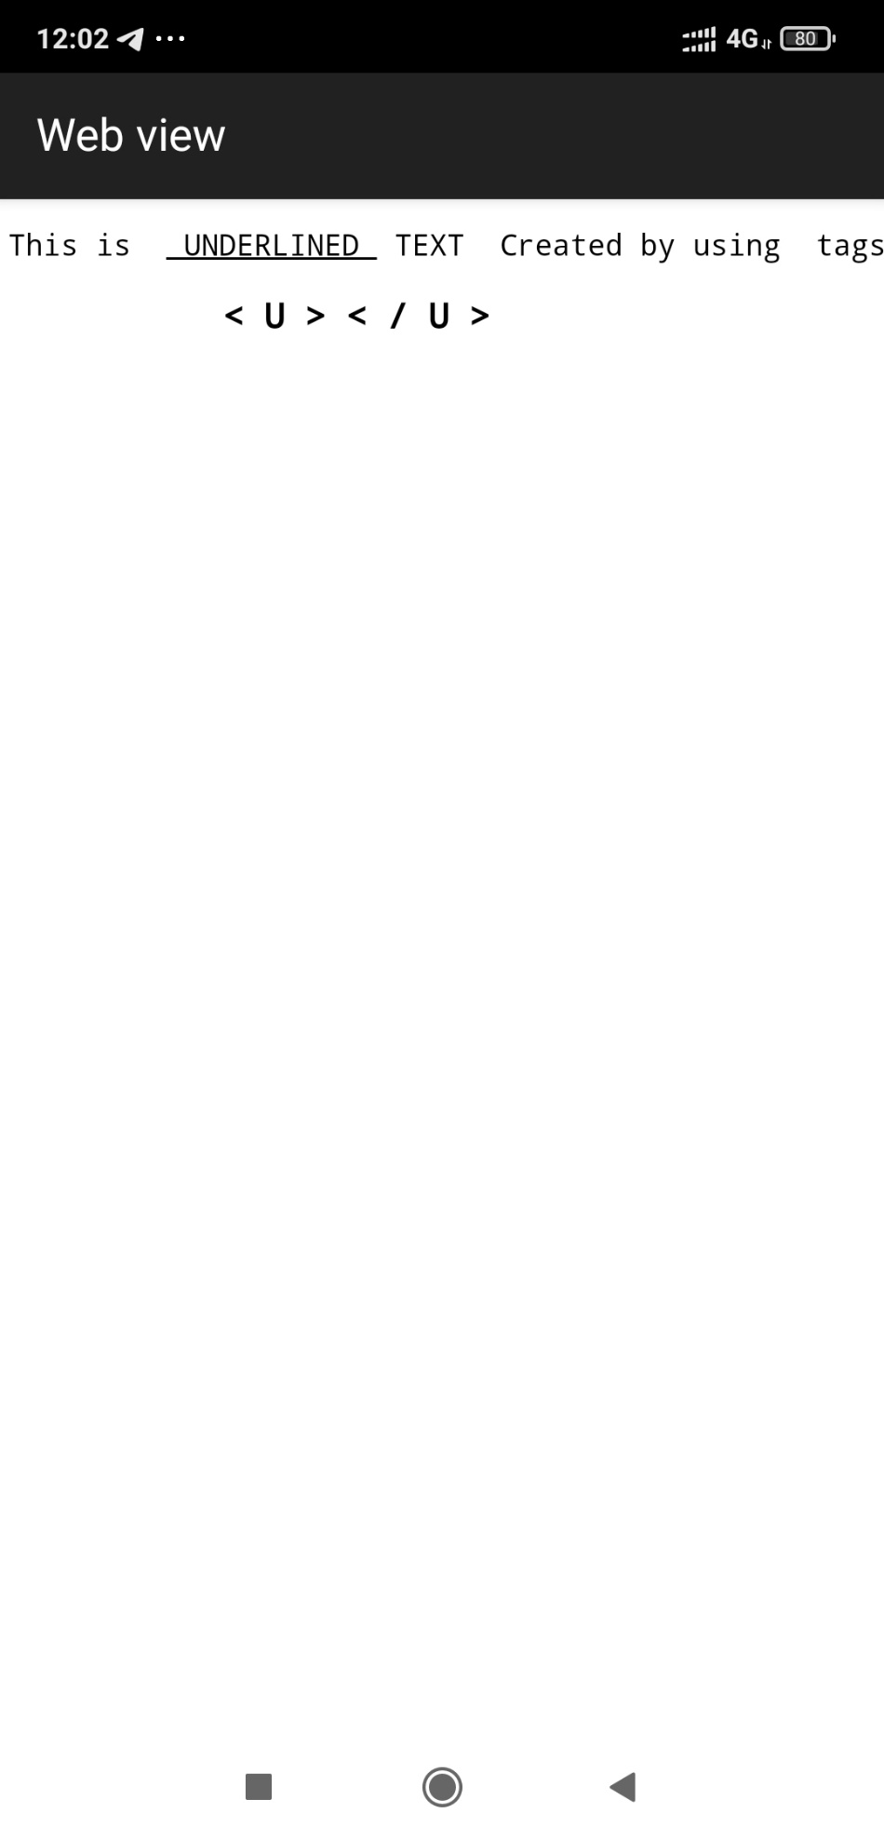

**2) Insertion**

**<!DOCTYPE html>**

**<html>**

**<head>**

**<Title> Insertion </Title>**

**</head>**

**<body>**

**<center>**

**<pre> This is <ins> INSERTED </ins> TEXT Created by using tags <h3> < ins > < / ins > </h3></pre>**

**</center>**

**</body>**

**</html>**

**Info :**

## **Definition and Usage**

The **<ins>** tag defines a text that has been inserted into a document. Browsers will usually underline inserted text.

**Output :**

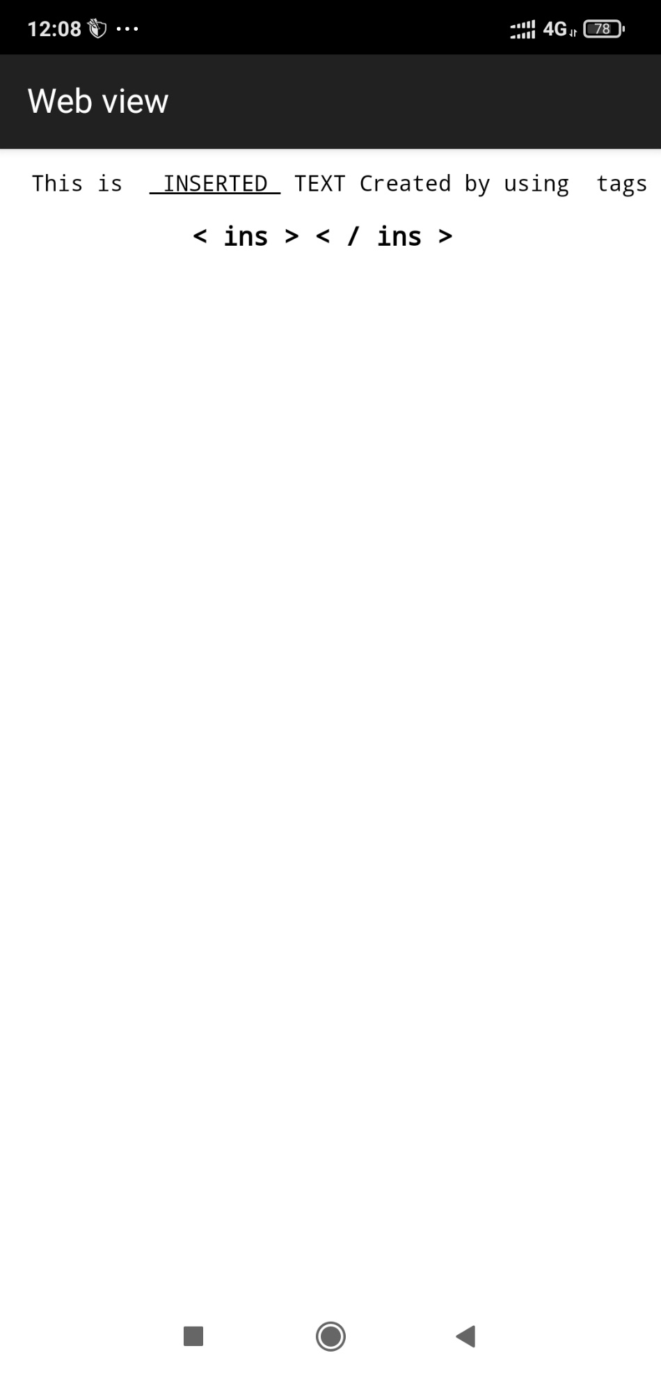

**4.)<!-- font remove /deletesome word then used tag's like**

**1) strike**

**<!DOCTYPE html>**

**<html>**

**<head>**

**<Title> Strike </Title>**

**</head>**

**<body>**

**<center>**

**<pre> This is <strike> STRIKED </strike> TEXT Created by using tags <h3> < STRIKE > < / STRIKE > </h3></pre>**

**</center>**

**</body>**

**</html>**

**Info :**

## **Not Supported in HTML5.**

The**<strike> t**ag was used in HTML 4 to define strikethrough text.

**Output :**

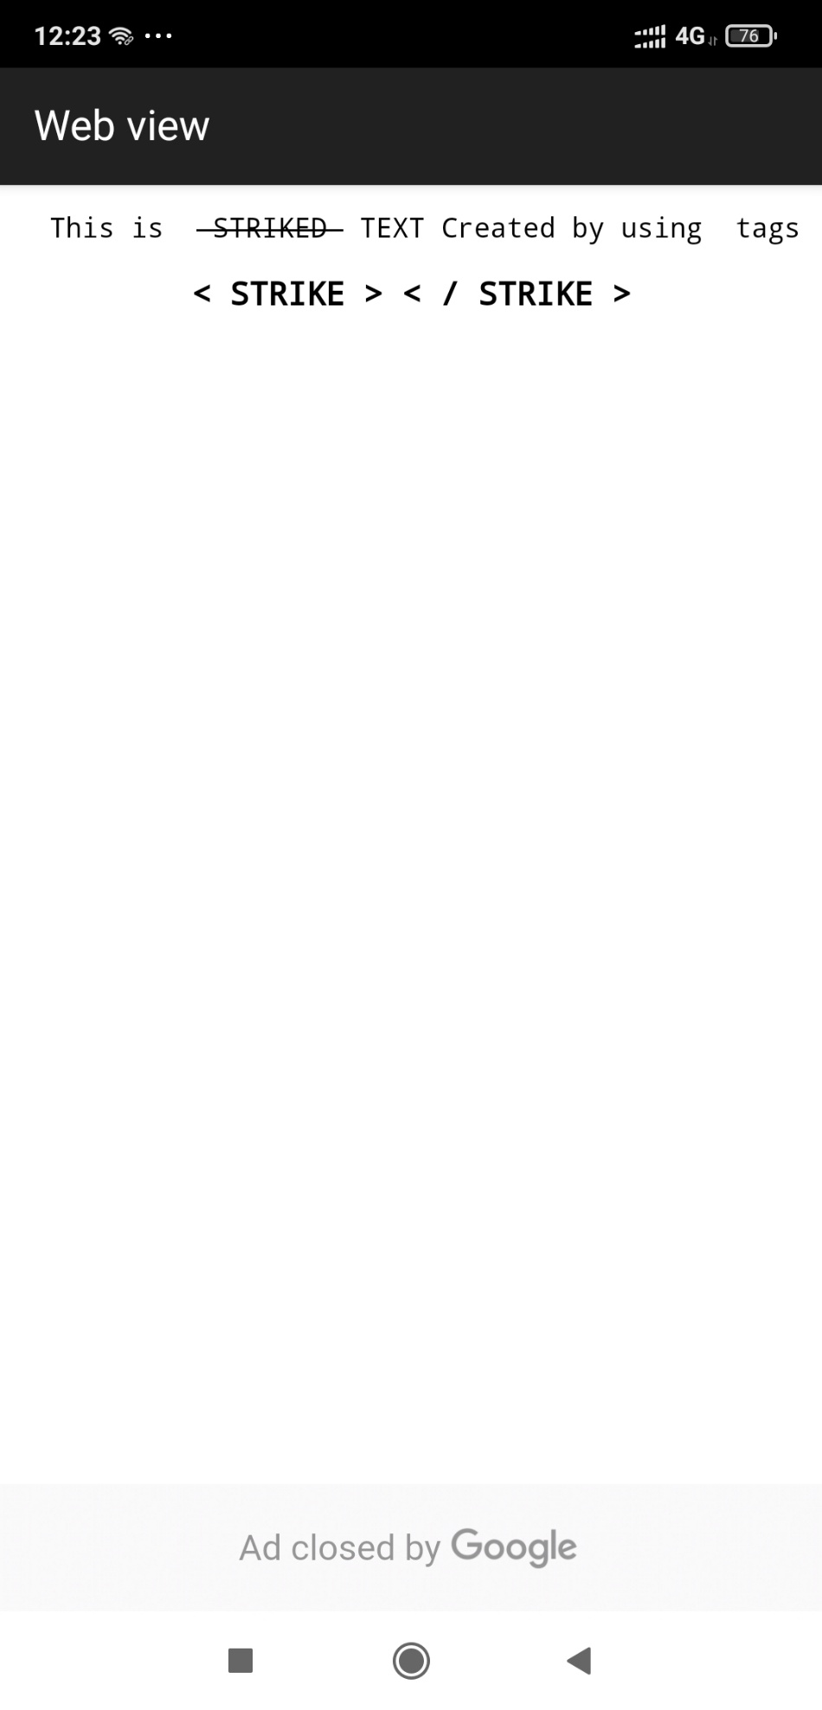

**2) Delete**

**<!DOCTYPE html>**

**<html>**

**<head>**

**<Title> Delete </Title>**

**</head>**

**<body>**

**<center>**

**<pre> This is <del> DELETED </del> TEXT Created by using tags <h3> < DEL > < / DEL > </h3></pre>**

**</center>**

**</body>**

**</html>**

**Info :**

## **Definition and Usage**

The **<del>** tag defines text that has been deleted from a document. Browsers will usually strike a line through deleted text.

**Output :**

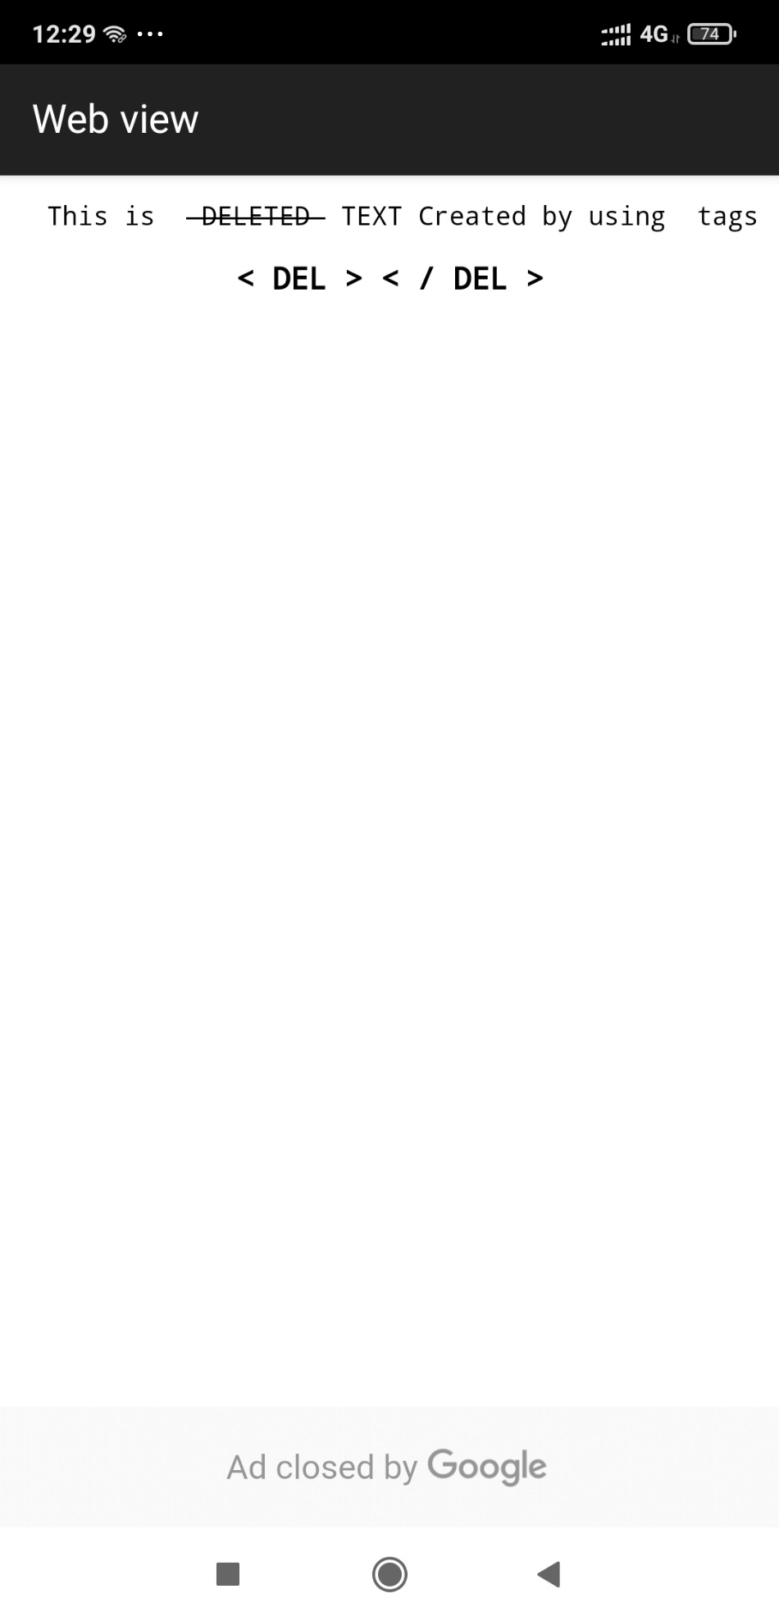

**5.)<!-- span /div used difference -->**

**1) span**

**<!DOCTYPE html>**

**<html>**

**<head>**

**<Title> Span </Title>**

**</head>**

**<body>**

**<center>**

**<pre> This is <span style=”color:red”;font-weight:bold>SPANED</span> TEXT Created by using tags <h3> < SPAN > < / SPAN > </h3></pre> </pre>**

**</center>**

**</body>**

**</html>**

**Info :**

## **Definition and Usage**

The <span> tag is an inline container used to mark up a part of a text, or a part of a document.

The <span> tag is easily styled by CSS or manipulated with JavaScript using the class or id attribute.

**Diffrence Between Span And Div :**

**The <span> tag is much like the**[**<div>**](https://www.w3schools.com/tags/tag_div.asp)**element, but <div> is a block-level element and <span> is an inline element.**

**Output :**

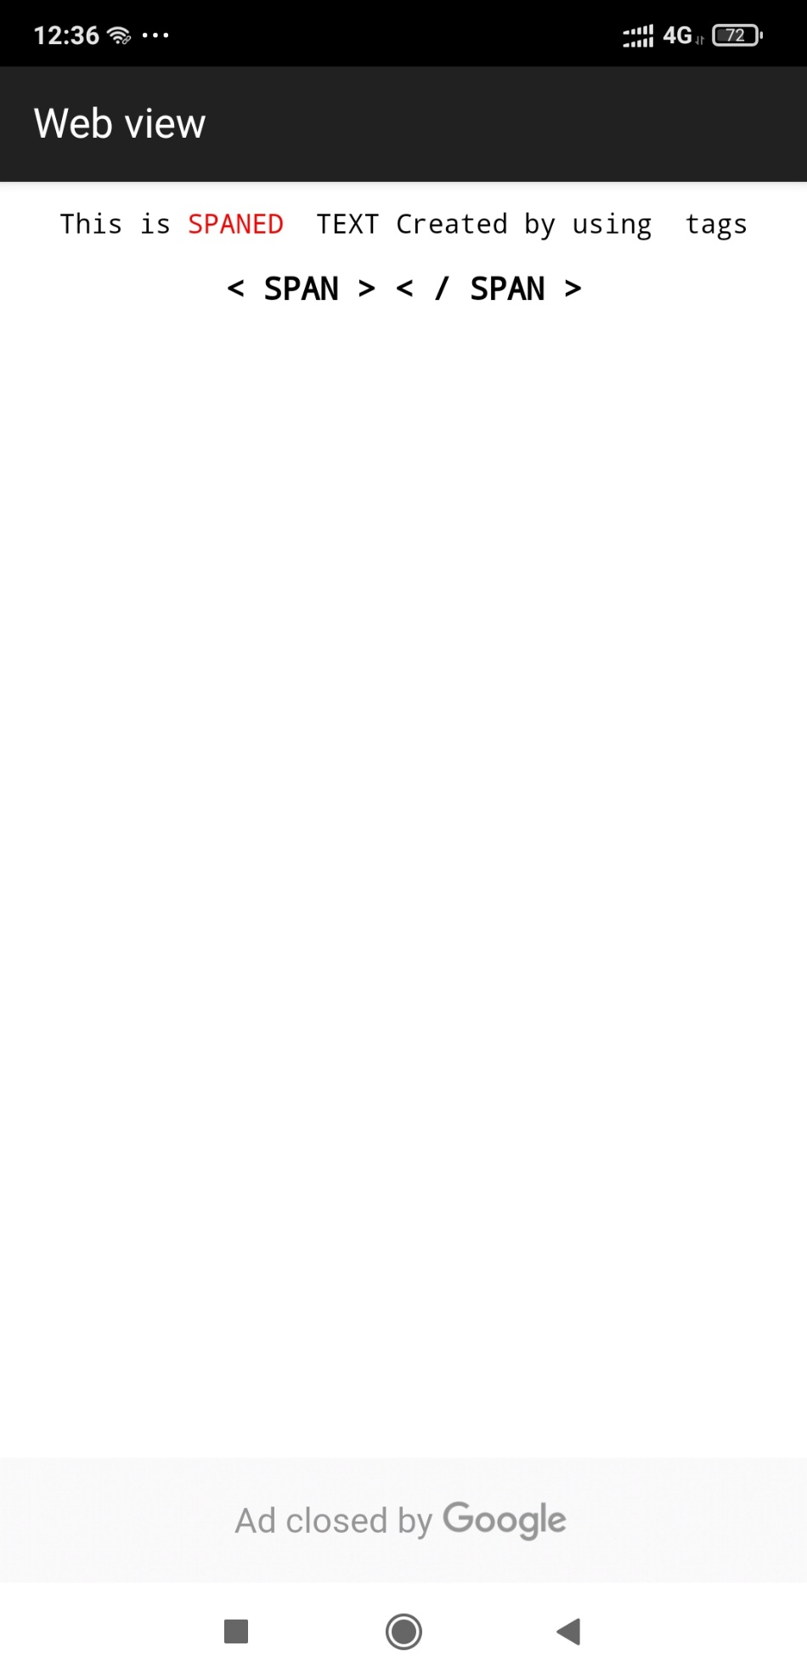

**2) Division**

**<!DOCTYPE html>**

**<html>**

**<head>**

**<Title> Division </Title>**

**<style>**

**.mydiv{**

**Border: 10px outset red;**

**Background-color:lightblue;**

**Text-align:center;**

**}**

**</style>**

**</head>**

**<body>**

**<center>**

**<pre><div class=”mydiv”>This Paragraph Created using Divison TAG<h3> < DIV > < / DIV > </h3></pre> </div>**

**</center>**

**</body>**

**</html>**

**Info :**

## **Definition and Usage**

The **<div>** tag defines a division or a section in an HTML document.

The **<div>**tag is used as a container for HTML elements - which is then styled with CSS or manipulated with JavaScript.

The **<div>** tag is easily styled by using the class or id attribute.

Any sort of content can be put inside the **<div>** tag!

**Output :**

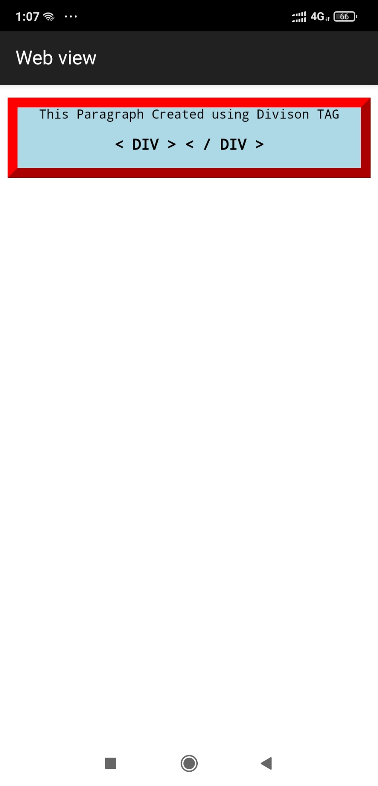

**6.)Paragraph**

**<!DOCTYPE html>**

**<html>**

**<head>**

**<Title> Paragraph </Title>**

**</head>**

**<body>**

**<p>This Paragraph Created using Paragraph TAG </p>**

**<p>This Paragraph 2 Created using Paragraph TAG </p>**

**</body>**

**</html>**

**Info :**

## **Definition and Usage**

The **<p>** tag defines a paragraph.

Browsers automatically add a single blank line before and after each **<p>** element.

**Output :**

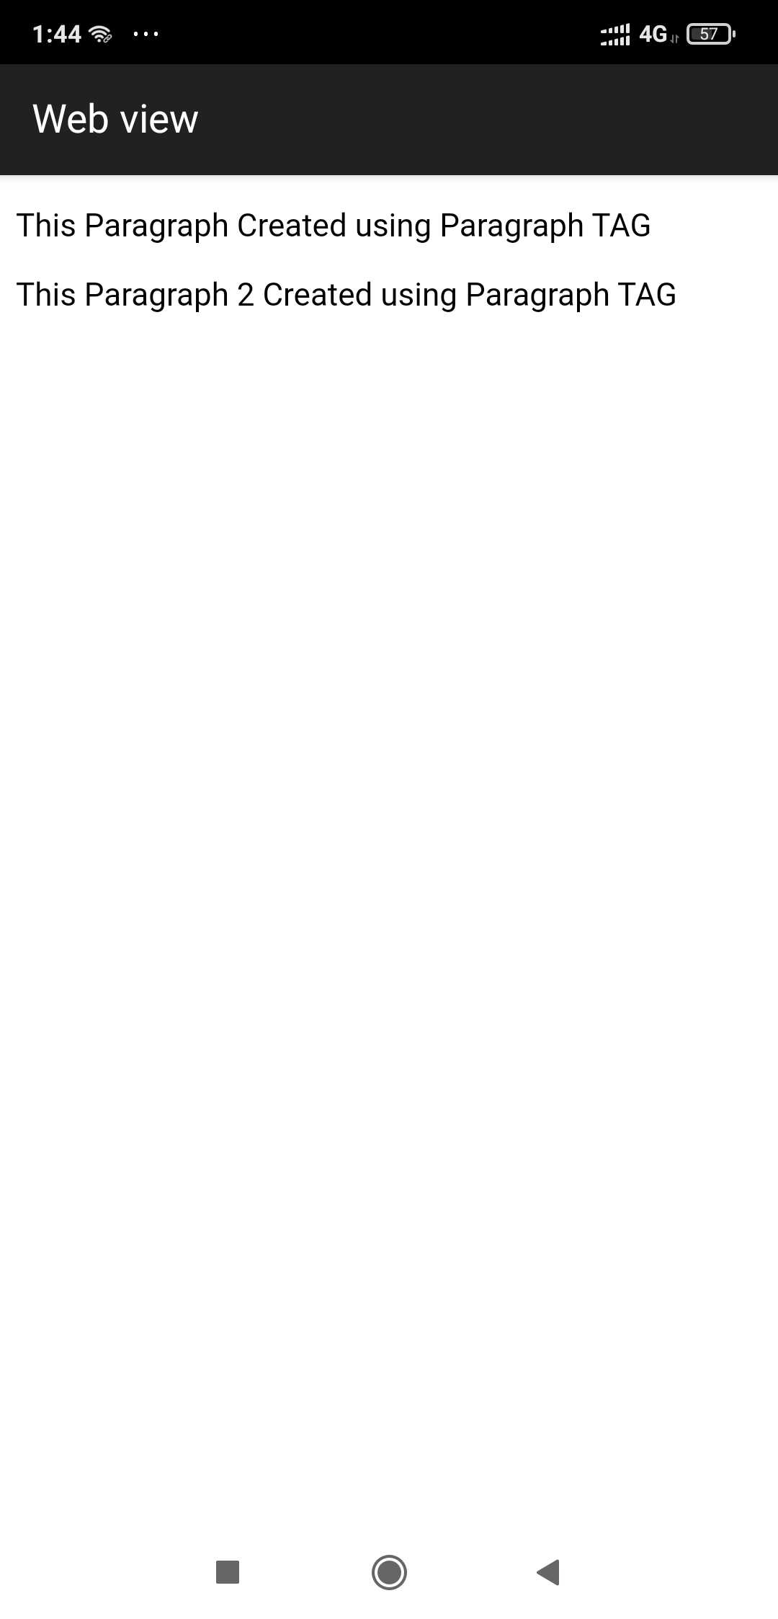

**7.)Blockquote**

**<!DOCTYPE html>**

**<html>**

**<head>**

**<Title> Blockquote </Title>**

**</head>**

**<body>**

**<center>**

**<block quote cite ="https://www.goggle.com.html">**

**A B C D E F G H I J K L M N O P Q R S T U V W X Y Z**

**A B C D E F G H I J K L M N O P Q R S T U V W X Y Z**

**A B C D E F G H I J K L M N O P Q R S T U V W X Y Z**

**A B C D E F G H I J K L M N O P Q R S T U V W X Y Z A B C D E F G H I J K L M N O P Q R S T U V W X Y Z**

**this is BLOCK CREATED USING BLOCKQUOTE**

**</block>**

**</center>**

**</body>**

**</html>**

**Info :**

## **Definition and Usage**

The **<blockquote>** tag specifies a section that is quoted from another source.

Browsers usually indent **<blockquote>** elements (look at example below to see how to remove the indentation).

**Output :**

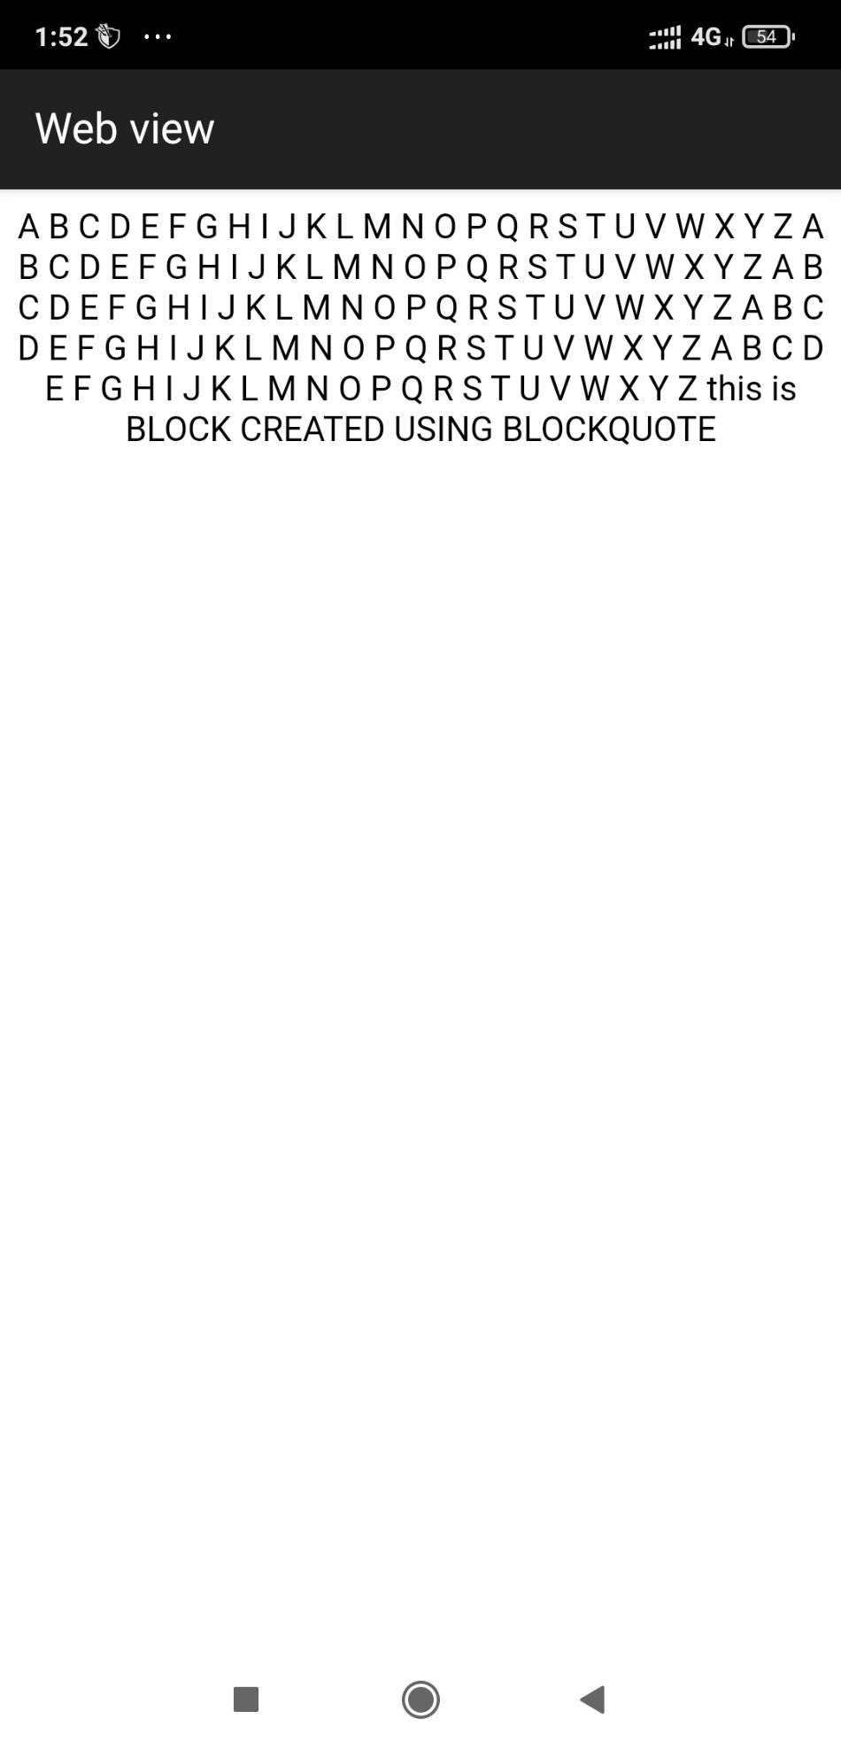

**8.)<!--sub and super -->**

**1) Subscript**

**<!DOCTYPE html>**

**<html>**

**<head>**

**<Title> Subscript </Title>**

**</head>**

**<body>**

**<center>**

**<pre> This is <sub>subscripted </sub> TEXT Created by using tags <h3> < SUB > < / SUB > </h3></pre>**

**</center>**

**</body>**

**</html>**

**Info :**

## **Definition and Usage**

The **<sub>** tag defines subscript text. Subscript text appears half a character below the normal line, and is sometimes rendered in a smaller font. Subscript text can be used for chemical formulas, like H2O.

**Output :**

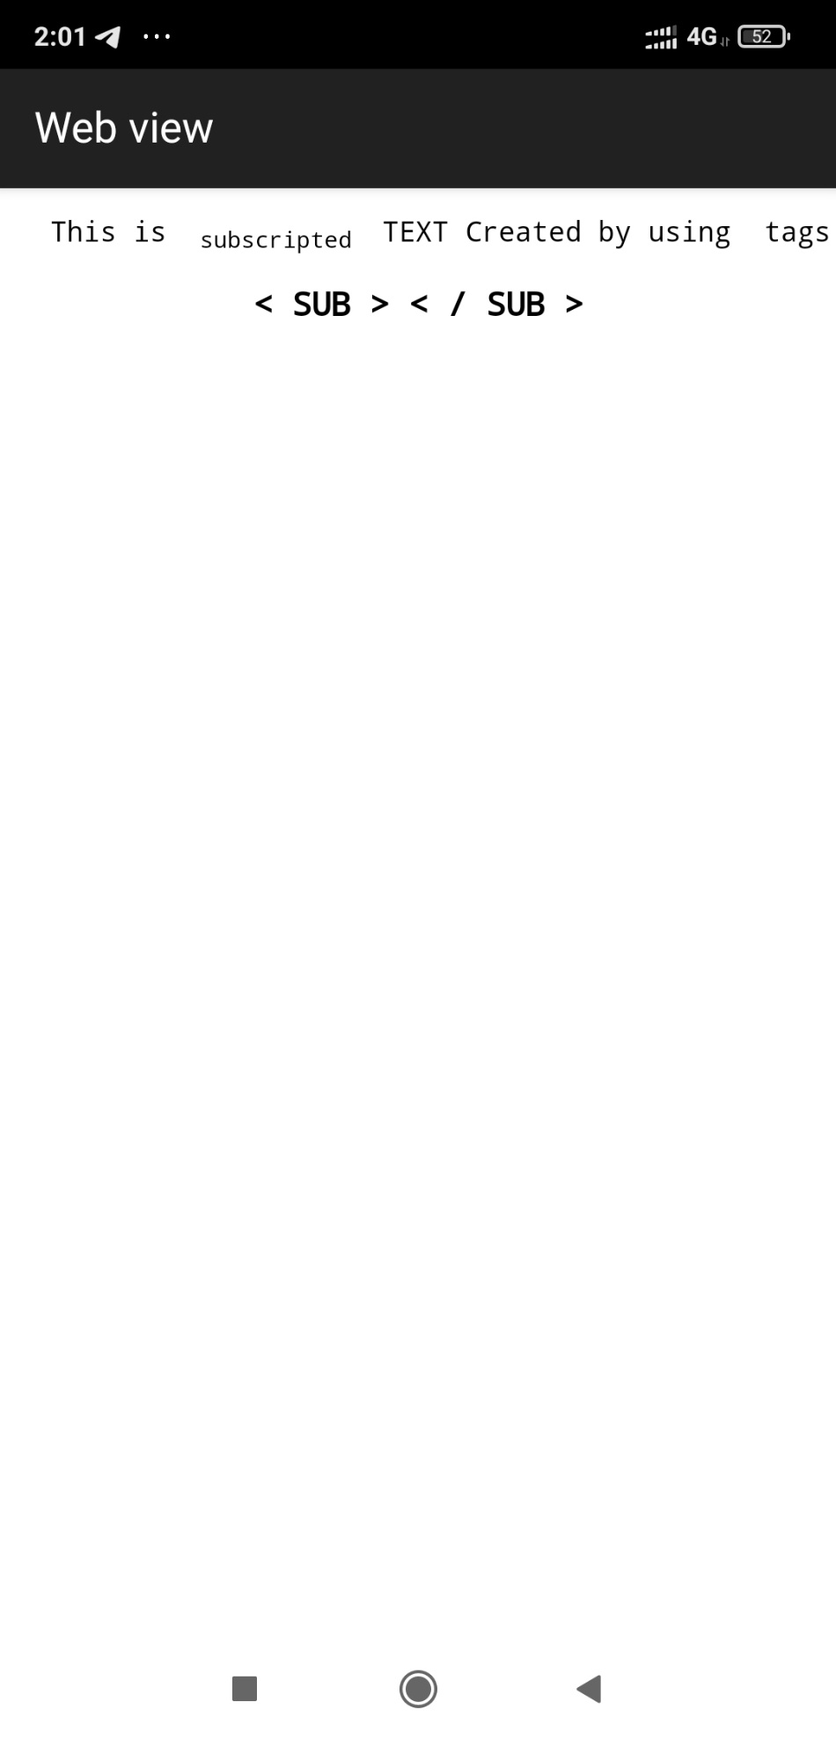

**2) Superscript**

**<!DOCTYPE html>**

**<html>**

**<head>**

**<Title> Superscript </Title>**

**</head>**

**<body>**

**<center>**

**<pre> This is <sup>superscripted </sup> TEXT Created by using tags <h3> < SUP > < / SUP > </h3></pre>**

**</center>**

**</body>**

**</html>**

**Info :**

## **Definition and Usage**

The **<sup>**tag defines superscript text. Superscript text appears half a character above the normal line, and is sometimes rendered in a smaller font. Superscript text can be used for footnotes, like WWW[1].

**Output :**

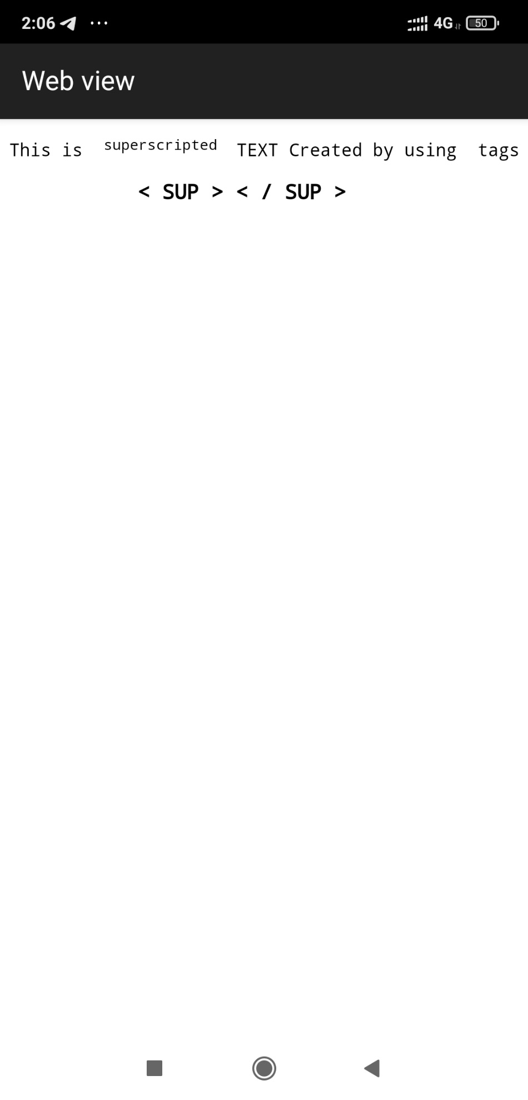

**9.)<!--abbr&acronym -->**

**1) abbr**

**<!DOCTYPE html>**

**<html>**

**<head>**

**<Title> Abbr </Title>**

**</head>**

**<body>**

**<center>**

**<pre> This is <abbr title="abribriation">ABBR</abbr> TEXT Created by using tags <h3> < ABBR > < / ABBR > </h3></pre>**

**</center>**

**</body>**

**</html>**

**Info :**

## **Definition and Usage**

The **<abbr>** tag defines an abbreviation or an acronym, like "HTML", "CSS", "Mr.", "Dr.", "ASAP", "ATM".

**Output :**

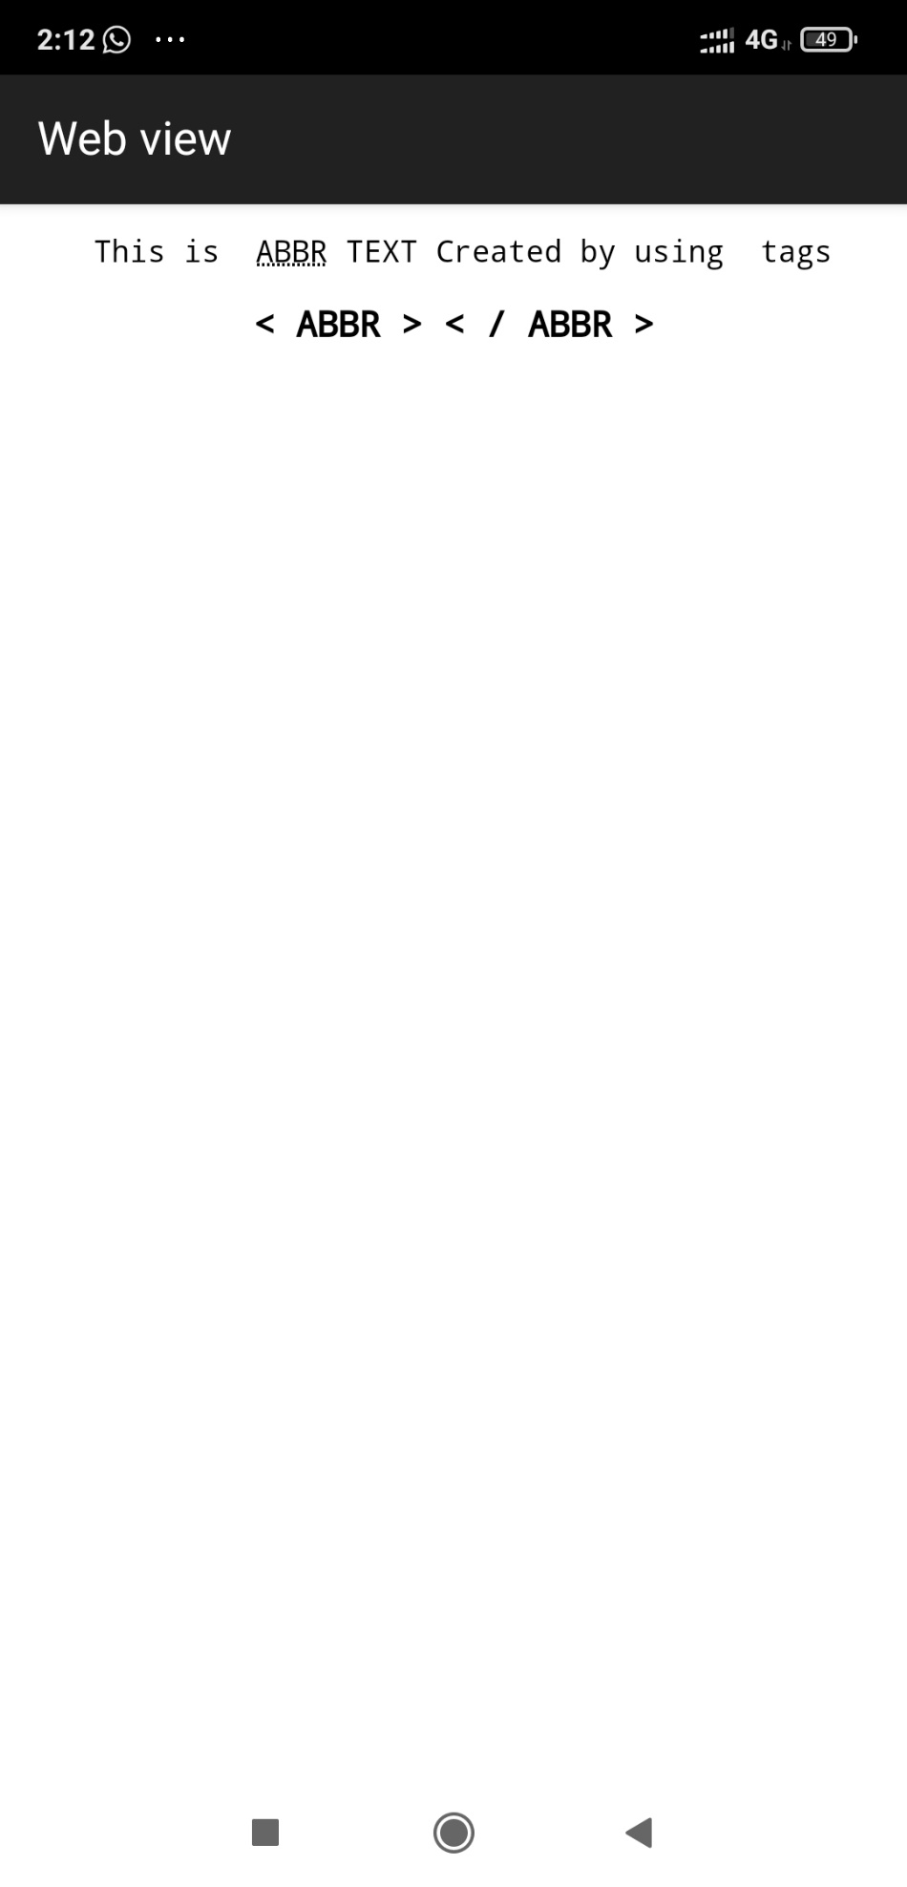

**2) Acronym**

**Not Supported in HTML5.**

**The <acronym> tag was used in HTML 4 to define an acronym.**

**10.)<!--&nbsp; and pre difference -->**

**1) &nbsp**

**<!DOCTYPE html>**

**<html>**

**<head>**

**<Title> &nbsp </Title>**

**</head>**

**<body>**

**<center>**

**this Space created using &nbsp &nbsp &nbsp &nbsp &nbsp &nbsp &nbsp SPACE <pre>& nbsp</pre> nbsp tag**

**</center>**

**</body>**

**</html>**

**Info :**

## **Non-breaking Space**

A commonly used entity in HTML is the non-breaking space: **&nbsp;**

A non-breaking space is a space that will not break into a new line.

Two words separated by a non-breaking space will stick together (not break into a new line). This is handy when breaking the words might be disruptive.

**Output :**

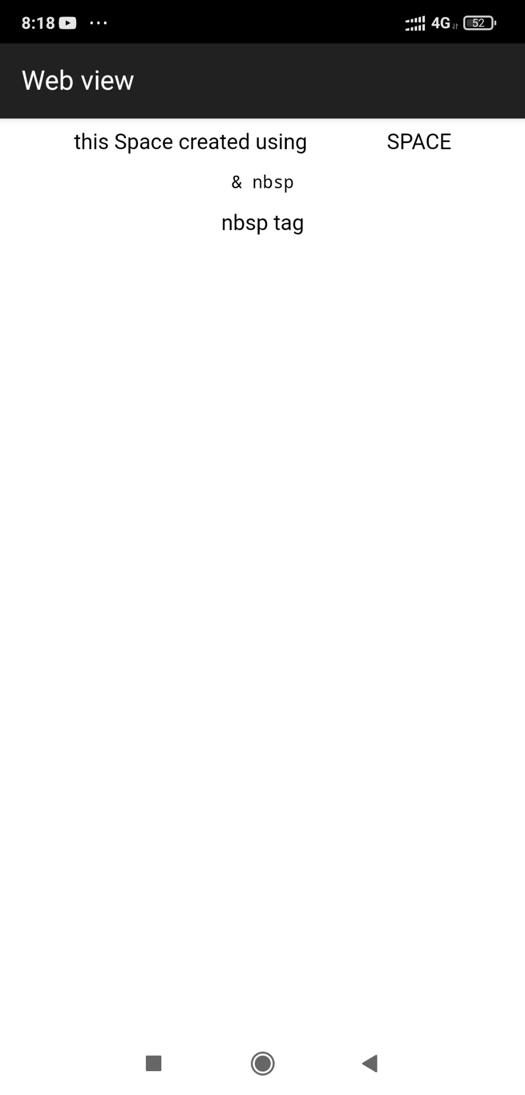

**2) preformatted text**

**<!DOCTYPE html>**

**<html>**

**<head>**

**<Title> Preformatted Text </Title>**

**</head>**

**<body>**

**below paragraph is created using < pre >< / pre > tag**

**<pre>A B C D E F G H I J K L M N O P Q R S T U V W X Y Z**

**A B C D E F G H I J K L M N O P Q R S T U V W X Y Z**

**A B C D E F G H I J K L M N O P Q R S T U V W X Y Z**

**A B C D E F G H I J K L M N O P Q R S T U V W X Y Z**

**</pre>**

**</body>**

**</html>**

**Info :**

## **Definition and Usage**

The**<pre>** tag defines preformatted text.

Text in a **<pre>** element is displayed in a fixed-width font, and the text preserves both spaces and line breaks. The text will be displayed exactly as written in the HTML source code.

**Output :**

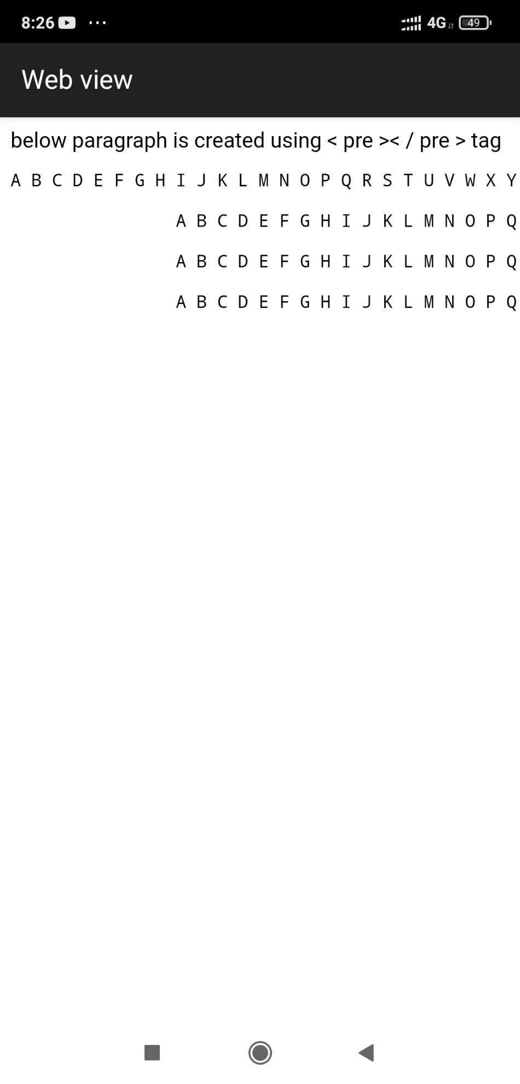

**11.)BOLD ,STRONG TAG**

**1) Bold**

**<!DOCTYPE html>**

**<html>**

**<head>**

**<Title>**

**Bold Text </Title>**

**</head>**

**<body>**

**<center>**

**<pre> This is <b>BOLD TEXT </b>Created by using tags <h3> < b > < / b > </h3></pre>**

**</center>**

**</body>**

**</html>**

**Info :**

**HTML <b>**

**The HTML <b> element defines bold text, without any extra importance.**

**Output :**

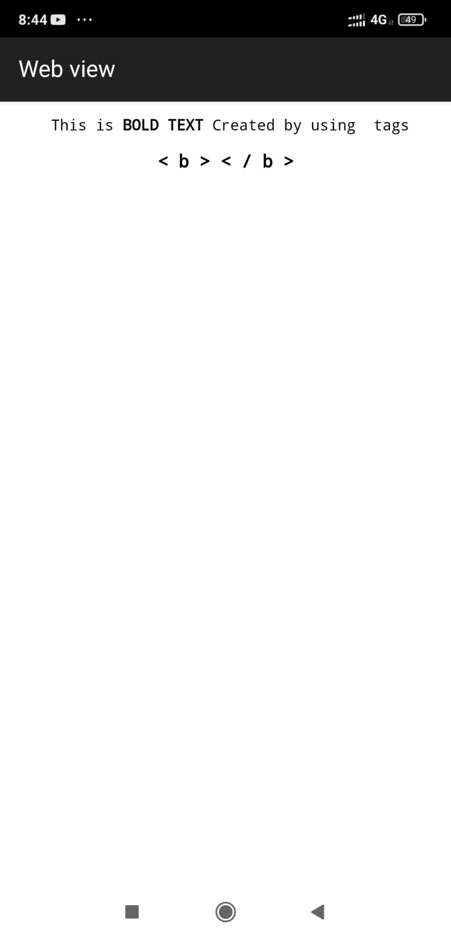

**2) Strong**

**<!DOCTYPE html>**

**<html>**

**<head>**

**<Title>**

**Bold Text </Title>**

**</head>**

**<body>**

**<center>**

**<pre> This is <strong> STRONG TEXT </strong>Created by using tags <h3> < strong > < / strong > </h3></pre>**

**</center>**

**</body>**

**</html>**

**Info :**

**Html <strong>**

The HTML **<strong>** element defines text with strong importance. The content inside is typically displayed in bold.

**Output :**

